# **Tasks**

**Learners have to develop a dashboard to support the answers to the following questions and suggestions for places for newer restaurants.**

**Objective Questions**:

1. What is the total no. of tables present in the data?

**Ans –** The data provided by newton school is consists of two tables which are raw data and country description and we created 7 pivot tables from that what we needed for analysis of restaurants.

1. What is the total no. of attributes present in the data

**Ans –** The total number of attributes present in raw sheet of newton school data is 20 but after doing data pre=processing it now consists of 23 attributes(columns) in the data.

1. How many categorical columns are there in the data? [Search about categorical and continuous data, and try to answer this question]

**Ans-** There are 17 categorical columns in the data:

RestaurantID

RestaurantName

CountryCode

Country Name

City

Address

Locality

LocalityVerbose

Has_Table_booking

Has_Online_delivery

Is_delivering_now

Switch_to_order_menu

Price_range

Votes

Average_Cost_for_two

Rating

Datekey_Opening

1. The data consists of some inconsistent and missing values so ensure that the data used for further analysis is cleaned.

**Ans –** Yes, we sure that what data we used is consistent and used concatenate and trim functions in data cleaning process.

1. Using the LookUp functions, fill up the countries in the original data using the country code.

**Ans –** Yes, we used Vlookup function to fetch the Country Names from country code.

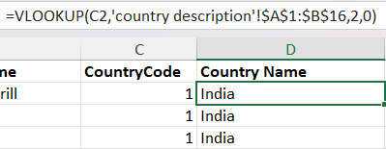

1. Create a table to represent the number of restaurants opened in each country.

**Ans –** Yes, we created number of restaurants per country pivot table.

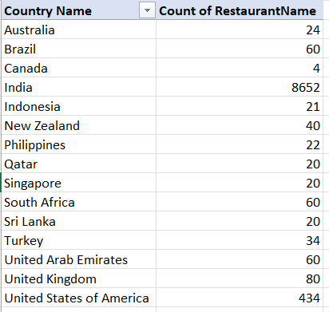

1. Also, the management wants to look at the number of restaurants opened each year, so provide them with something here.

**Ans –** Yes, We Created Year wise restaurants opened pivot table .

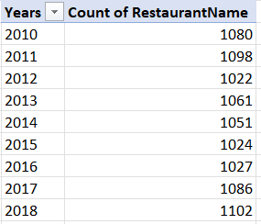

1. What is the total number of restaurants in India in the price range of 4?

**Ans –** Yes, Here we used the formula to get the answer that is 388

=COUNTIFS('Raw Data'!D:D,"India",'Raw Data'!Q:Q,"4")

1. What is the average number of voters for the restaurants in each country according to the data?

**Ans –** Yes, Here we created the pivot table of Average number of voters per restaurants .

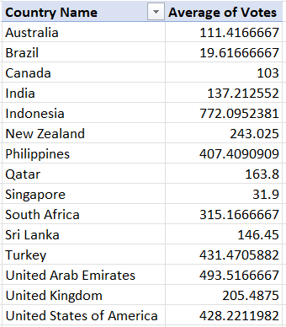

1. Calculate the average rating for all the restaurants that have price_range < 4 and provide online delivery. Use only the “IF” function, Logical Operators, and Aggregation functions to solve this problem. **[Note: Don’t use Conditional aggregation in this question.]**

**Ans –** Yes, Here we calculate the average rating for all the restaurants that have price_range < 4 and provide online delivery using aggregation functions that is 3.8908

=IF(AND('Raw Data'!Q:Q,">4",'Raw Data'!N:N,"Yes"),AVERAGE('Raw Data'!T:T))

1. Using Conditional formatting highlight the rows of restaurants that are located in the countries or cities that you’ve suggested to the management for opening new restaurants.

**Ans –** Yes, we highlighted the countries as green where the restaurants count is less than 25 So, have less competion and here we can open new restaurants (in Raw data)

1. Create a new customized price column that consists of the abbreviation/symbol of the currency along with the Average_cost_for_two value. [Use string operations to do this task]

**Ans –** Yes, here we created new column where we use concatenate function to get customized price column

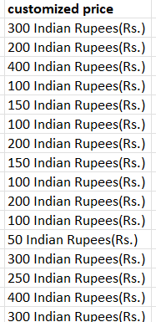

1. How can you create an array formula in Excel or Google Sheets to count the number of restaurants listed that do not offer online delivery, are in the lowest price range, and have an average cost for two people less than or equal to 250 Indian Rupees?

**Ans –** Yes, here we use the Counifs function for count the number of restaurants listed that do not offer online delivery, are in the lowest price range, and have an average cost for two people less than or equal to 250 Indian Rupees.

=COUNTIFS('Raw Data'!O:O, "No", 'Raw Data'!R:R, "<=2", 'Raw Data'!X:X,"<=Rs.250")

**Subjective Question:**

1. Suggest a few countries where the team can open newer restaurants with lesser competition. Which visualization/technique will you use here to justify the suggestions?

Ans – Here we consider four factors to suggests the countries where the team can open newer restaurants with lesser competition.

The four factors are as follows:

1. Restaurants Count Per Country
2. Ratings of Restaurants
3. Rating For Online Delivery Availability
4. Rating For Table Booking Availability

Countries where team can open new restaurants are as follows :

1. Australia
2. Brazil
3. India
4. New Zealand
5. Sri Lanka
6. United Arab Emirates
7. United Kingdom
8. United States of America

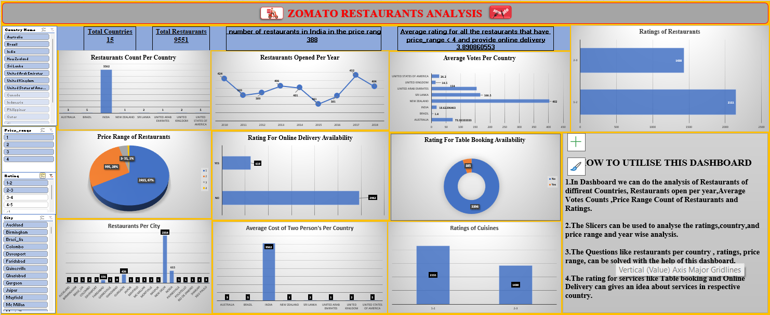

1. Come up with the names of States and cities in the suggested countries suitable for opening restaurants.

**Ans –**

**Australia** :- Mayfield , Montville , Paynesville

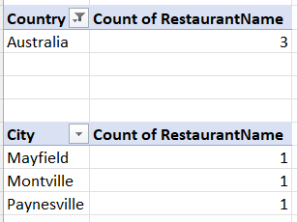

**Brazil :-** Brasí_lia , Rio de Janeiro , Sí£o Paulo

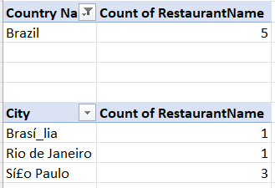

**India :-** Faridabad , Ghaziabad , Gurgaon , Jaipur , Nagpur , New Delhi , Noida

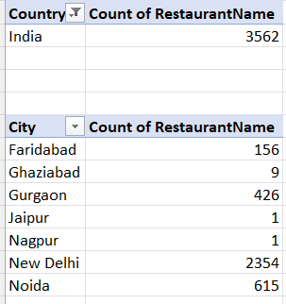

**New Zealand :-** Auckland

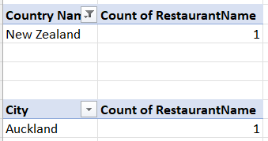

**Sri Lanka :-** Colombo

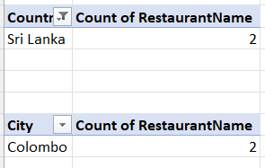

**United Arab Emirates :-** Sharjah

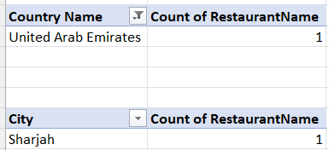

**United Kingdom :-** Birmingham

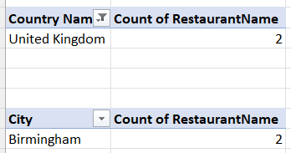

**United States of America** :- Davenport , Gainesville , Mc Millan , Pocatello

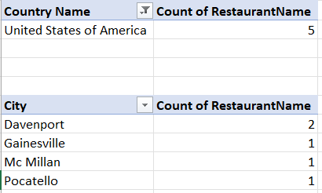

1. According to the countries you suggested, what is the current quality regarding ratings for restaurants that are open there?

**Ans –** Here are the current quality regarding ratings for restaurants that are open there.

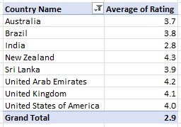

1. Also, what is the current expenditure on food in the suggested countries, so we can keep our financial expenditure in control?

**Ans -** As per the current calculation if we issue a pivot chart for average customized vs average of ratings and name of restaurants suggested, we can see that most of them falls between 623 Rs. To 5,016 Rs.

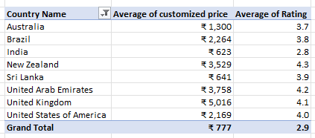

1. Come up with the names of restaurants from the recommended states that are our biggest competitors and also those that are rated in the lower brackets, i.e. 1-2 or 2-3

**Ans –** Yes, here we use Pivot table and apply filters on country ,city and Restaurants name so, we get the names of restaurants from the recommended states that are our biggest competitors and also those that are rated in the lower brackets

* + - Inserted Pivot table.
    - Took “Rating” as Highest rating in filter.
    - Took “City” as Suggested Cities one by one in filter
    - Get Restaurant name for each City as below –

|  |  |  |  |
| --- | --- | --- | --- |
| **Recommended Cities for India** | **New Delhi** | **Noida** | **Gurgaon** |
| Biggest Comptitor | Indian Accent - The Manor | Movenpick | Caterspoint |
| Low Comptitor | #hashtag | Let's Burrrp | Achoos Food Corner |
|  |  |  |  |
|  |  |  |  |
| **Recommended Cities for USA** | **Gainesville** | **Davenport** |  |
| Biggest Comptitor | Atlanta Highway Seafood Market | Tantra Asian Bistro |  |
| Low Comptitor | No Low Comptetior | Frick's Tap |  |
|  |  |  |  |
|  |  |  |  |
| **Recommended Cities for Brazil** | **Sí£o Paulo** |  |  |
| Biggest Comptitor | Skye - Hotel Unique |  |  |
| Low Comptitor | Cantinho da Gula |  |  |
|  |  |  |  |
|  |  |  |  |
| **India** | **Brazil** | **United States of America** |  |
| North Indian, Mughlai | Brazilian | Mexican |  |
| North Indian | Brazilian, Bar Food | American |  |
| North Indian, Chinese | Italian | Pizza |  |

1. Which cuisines should we focus on in the newer restaurants to get better feedback? Does the choice of cuisines affect the restaurant ratings?

**Ans –**

* Add column name” Cuisines with Rating>4” to get all rating which is greater than 4.
* Inserted Pivot table.
* Took “Country” as India in filter.
* Took “Cuisines” in row.
* Took Count of “Cuisines With Rating>4” in values
* Sorted the list
* **Suggested Cuisines for India–**

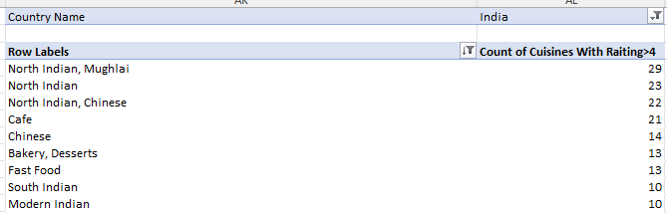

With the help of above graph, we could say that top cuisines like “North India, Mughlai”, “North Indian”, “North Indian Chinese” are the cuisines on which we could focus while opening new restaurant. Like this we can calculate for other countries.

1. According to our current data, should we go for online delivery and table booking? Does that affect the customer’s ratings?

**Ans –** If we use a filter on Online delivery/ Table booking category, we get mixed responses along with exceptionally good ratings. So as per my calculations, we should try for these options as these to be considered most versatile of them all and people likes versatility, and this data is based on suggested countries only.

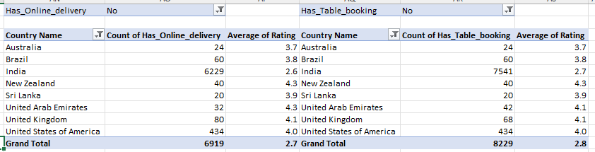

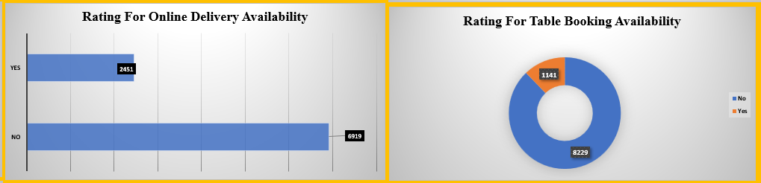

1. Should the team keep the rate of cuisines higher? Will that affect the feedback? According to our data are the rates of cuisines and ratings, correlated?

**Ans –** Yes, According to the data analysis, there is a positive correlation between higher cuisines rates and better ratings, Therefore, maintaining high rates is the recommended strategy.

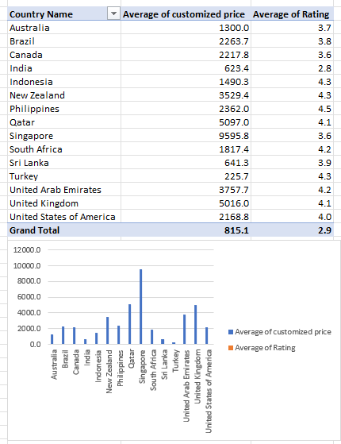

1. What is the distribution of the number of restaurants of different price ranges in all the countries?

**Ans -**

**Ans -** 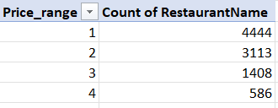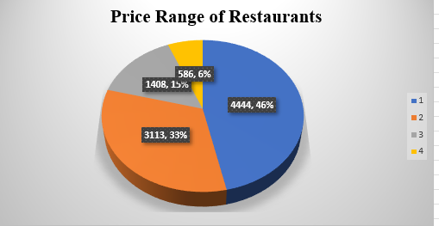

1. Explain your approach in brief for suggesting countries/cities in order to open new restaurants, if the objective and subjective questions would have been given to assist you. **[you have to give bullet pointers in order to answer this question]**

**Ans –**

* Research competition levels in different countries.
* Analyze customer ratings and feedback.
* Consider economic factors like food expenditure.
* Visualize data for clearer insights.
* Prioritize countries with lower competition and positive customer feedback.